# **Holmgren Engineering – Case Summary**

The company Holmgren Engineering manufactures products which can store water along with pressure heating systems. There are basically five models. The models vary in design aspects that of storage capacity and dimensions. The company currently employs batch production which of batch of five in a layout that is organized haphazardly (refer Figure 1). The company has witnessed a continuous increase in sales but a slight fall in profits over last few years.

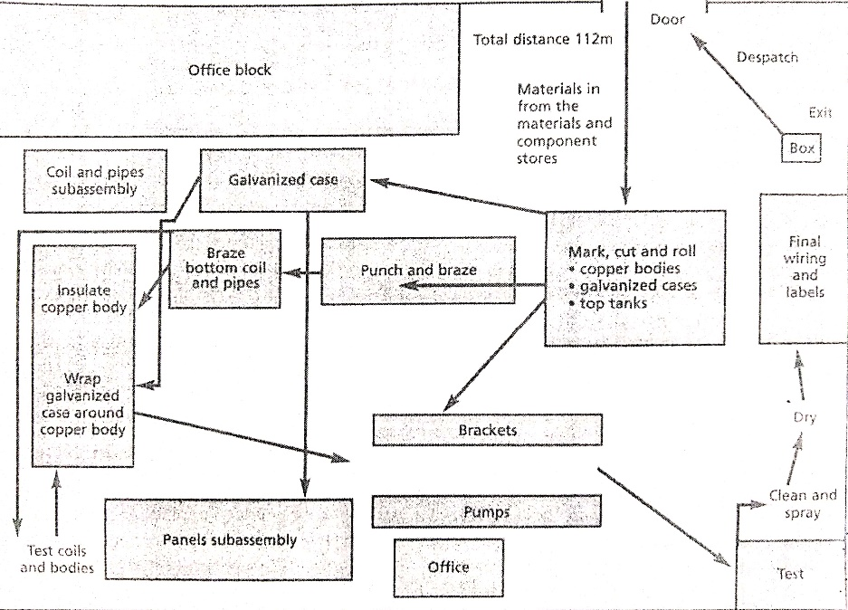

**Figure 1 : Haphazard layout**

|  |  |  |  |
| --- | --- | --- | --- |
|  | **Year 1** | **Year 2** | **Year 3** |
| **1.Sales Revenue** | 100.0 | 111.5 | 125.6 |
| **2.EBIT(% Sales Revenue)** | 10.3 | 8.6 | 7.4 |
| **3.Inventory(SKr000)^2** |  |  |  |
| **a.RM and Components** | 3,144 | 5,052 | 5,352 |
| **b.WIP** | 180 | 144 | 168 |
| **c.Finished Goods** | 720 | 924 | 1,680 |
| **Total** | 4,044 | 6,120 | 7,200 |

Notes: 1. EBIT= Earnings before interest and taxes

2.SKr= Swedish Krona

3.WIP includes issued materials and part-made products.

**Figure 2 : Sales and Revenue- Current and past two years**

The company currently employs short term forecasting method with week 1 fixed and week 2-4 tentative. The parts to be used are ordered in bulk and delivered on the first day of the week. The components are held in the material and components stores located on the same site but different building.

The production engineering head(PED) has made a suggestion to the top management to modify the process into a one-piece flow method, restructure the facilities layout into a U-shaped assembly line, and transform the orientation into a make-to-order process. The benefits of this proposed variations will make the company achieve its goal of:

* Cost advantage
* Process simplification
* Inventory management.
* Reduction in delivery lead time.

Also, the implementation of the changes will free up space in the shop floor which would create an opportunity for the company to range the product line or increase the capacity of the production. Refer Figure 2 for the organised U-shape layout

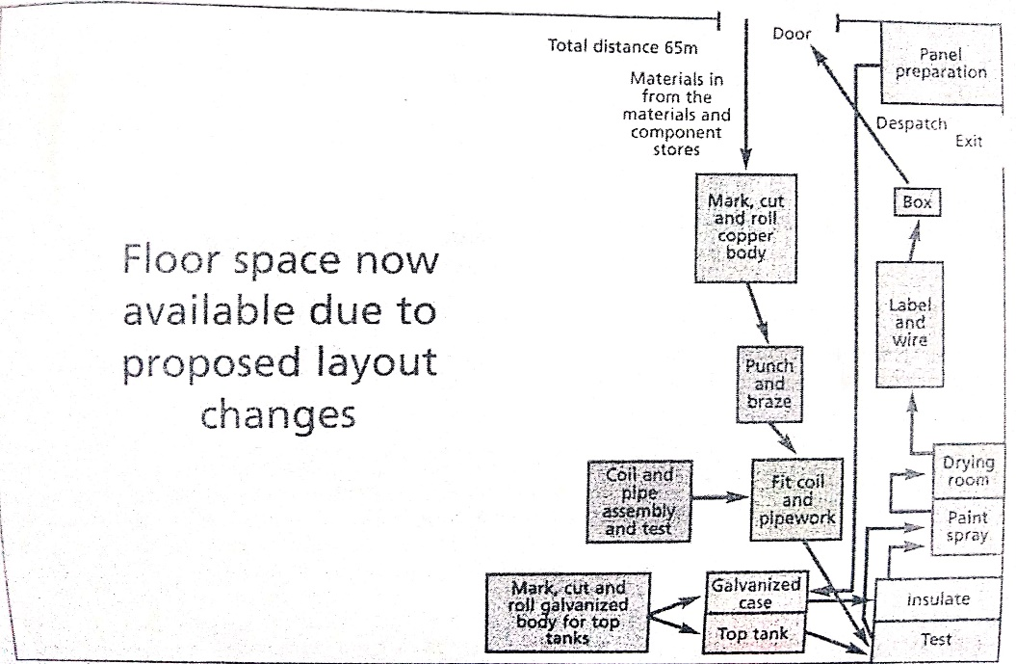

**Figure 3 : Structured U-shape Layout**

Holmgren Engineering is a manufacturing company with core capabilities in developing, manufacturing, and selling of water storage that include main pressure heating system. The products are marketed and sold under Hetvatten Plus trademark. The product range comprises of five models with different storage volumes, dimensions and dwelling type usage.

Holmgren Engineering has progressed from a self-effacing heating engineering firm, started by its founder Benny Holmgren, into a full-service manufacturing firm under the umbrella of Karlsson Invest corporation. The present CEO is John Svensson. Peter Wiklund is the production engineering head who made suggestions and recommendations for changes in the existing operations process. They have designed and determined based on the following Likert table:

**Table 1 : Evaluation of alternative approaches to manufacturing, used as a basis for selecting the changes to be introduced**

|  |  |  |  |  |  |  |  |  |  |
| --- | --- | --- | --- | --- | --- | --- | --- | --- | --- |
| Alternatives | MTO vs MTS | Sub assembly stock | Dimension and score (1= Good, 4=Poor) | | | | | | Total score |
| Efficiency | Inventory | Speed of through-put | Space/ movement | Response/ variability | Quality |
| 1 | MTS | Yes | 1 | 4 | 3 | 4 | 3 | 4 | 19 |
| 2 | MTS | No | 3 | 3 | 4 | 3 | 3 | 2 | 18 |
| 3 | MTS | Yes | 2 | 3 | 1 | 2 | 3 | 2 | 13 |
| 4 | MTS | No | 4 | 2 | 2 | 1 | 3 | 1 | 13 |
| 5 | MTO | Yes | 1 | 3 | 3 | 4 | 1 | 4 | 16 |
| 6 | MTO | No | 3 | 2 | 4 | 3 | 1 | 2 | 15 |
| 7 | MTO | Yes | 2 | 3 | 1 | 2 | 1 | 2 | 11 |
| 8 | MTO | No | 4 | 1 | 2 | 1 | 1 | 1 | 10 |

This report will primarily examine the current operations procedure used by Holmgren Engineering. The key structures of the current process will be discussed and estimated rendering to their advantages and disadvantages. It will then inspect the main changes of the proposal made by Wiklund. His suggestion is the re-engineering of the procedure which would create a U-shaped manufacturing layout engaging a one-piece flow orientation. Introduction of make-to-order method was suggested together with the new procedure. The costs on new investments and profits that the company will improvement from the proposal will be analysed. Several features are recognized that should be reasonably accomplished in order to successfully implement the variations and will be discussed in the latter part of the report. Conclusions and references in the last part will summarise the report in a nutshell.

Summary of the Proposed Changes by Product Engineer

|  |  |
| --- | --- |
| **BEFORE** | **AFTER** |
| 1. Haphazard Layout | 1. Structured U-shaped Layout |
| 1. Batch Processing (batch of 5) | 1. One-piece flow of work. |
| 1. Make-to-Stock | 1. Make-to-Order with Sub-assembly stock |
| 1. Weekly call-offs | 1. Just-in-time processing used |
| 1. Manually movement of boilers around the line | 1. Boilers moved around the line using trolleys. |

# **Merits and Demerits of the planned changes**

|  |  |
| --- | --- |
| **Merit** | **Demerit** |
| * Nearly 50% free up in floor space. Thus, reduction in labour content and reduction in distance travelled by typical product. | * No risks and uncertainty taken into consideration. |
| * Work in progress inventory will be reduced to SKr 36000 | * No importance given to frequency of ordering. |
| * One-piece flow of work and Sub assembly stock. | * Make-to-order can at times give scope to customer to prefer other company cause of delay in product. |
| * Better human resource management and cost efficiency. |  |

# **Analysis of various alternatives (Referring to table 1)**

* Option 1: Inventory overload, no free space movement and poor quality.
* Option 2: Relatively poor efficiency, inventory, space and response, but better quality.
* Option 3: Speedy process, relatively good efficiency, space movement and quality.
* Option 4: Good space movement and quality, poor efficiency and response.
* Option 5: High efficiency and response, poor space movement and quality.
* Option 6: Good response but very slow process and poor space movement.
* Option 7: Good speed and response, fairly good efficiency and quality, quite high inventory.
* Option 8: Good space movement, response, quality and inventory, however poor efficiency.

Analysing the above options vis-à-vis total score in the table, option 8 seems the best score. However, the efficiency level is least and very poor. Henceforth this alternative is inappropriate.

Option 3 however is not extreme in any aspect and has a fair total score of 13. This alternative can be chosen if there is no option 7. However, space might be occupied since there is presence of subassembly stock along with MTS stock. But since, sales are increasing, there will be not be any huge stock of finished goods. Hence option 3 can be preferred.

# **Discussion/Analysis of Case Questions**

1. **Examine the present operations process adopted by Holmgren Engineering. Explain the key features of this way of making products.**
2. Batch Process

The existing process of manufacturing boilers in Holmgren Engineering is batch process. The operations process includes four principal sub-assemblies of copper body, top tank, galvanised casing and the electrical unit. These sub-assemblies are produced in various tasks, systems and equipment.

A batch technique is a manufacturing system that produces group of items that are essentially identical, called production lots or batches. The technique utilises specialised equipment and expert people. Holmgren Engineering's products, which have small deviation in strategies of five models and average amount of demand, fit the requirements of the batching process. The damage, if happens, will ruin the production of the boiler in only that batch. In addition, the production can be easily monitored in batch process with less wastage.

Though batch production may seem feasible at first glance it however creates delays. Because the production lines must halt between batch runs. These delays can be problematic if they interfere with getting products to customers in a timely manner. In this process, as the process involves several steps and machine, there will be bottlenecks and the downtime can be huge.

1. Make-to-Order

In make-to-order, products are manufactured upon receiving a customer's order. The lead time in the given case for the delivery of the product throughout Sweden and parts of Europe is three to four weeks. Hence, make to order with a batch process does fit in the given production line of boilers. In addition, Sweden being a country with comparatively short and cooler summers, the need for the manufactured product is rarely off season.

Efficiency as far as layout design is concerned as majority of stock is subassembly stock and hence there is free space available for other employee recreational activities. Consequently, delivery lead time will be reduced to a great extent.

1. **What are the key changes that enable the proposed method (one-piece flow) to work?**

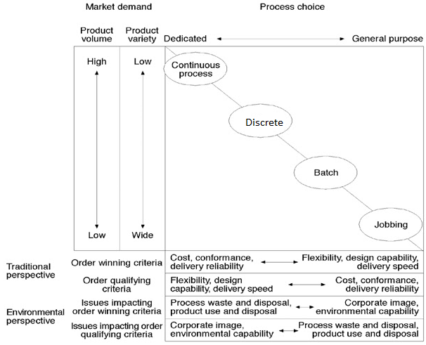

**Figure 4 : Deciding the Process**

From the diagram above, it is evident that One-piece flow of work i.e., Discrete process is applicable to produce water heater storage system as the product variety is comparatively less and production is intermediate.

* The change in the layout from haphazard to U-shaped makes the process flow of work easier and it also saves time.
* Sub-assembly stock suggested will aid in speeding up the one-piece flow of work.
* One-piece flow of work will help attaining just-in-time manufacturing with subassembly stock in hand.

Other perceived benefits of one-piece flow of work are:

* Increases flexibility: Compared to batch process, one-piece flow of works increases flexibility in the way that there will be no work in progress either be one unit or a batch of units at a time.
* Increases quality: When we opt for “make one, move one”, defects are detected immediately (usually the next workstation) forcing immediate corrective action.
* One of the advantages of Just-in-time manufacturing is zero lead time.

1. **Evaluate the benefits of these proposed changes and highlight the principle gains to be made.**

* Reduction in the delivery lead time from 3-4 weeks.

The proposed changes although uses make-to-order, subassembly stock will help speeding up the production process once the order is received. Thus, time spent on designing, tracking, and assembling the components is reduced.

* Increases operational efficiency.

Opposed to the earlier procedure of batch processing, the combination of make-to-order and sub-assembly inventory will reduce the operational time and help building quality assurance. Sub-assembly units are inspected to ensure the required specifications.

* The proposed change in the layout that is to U-shape, frees up the floor space which can be useful in following ways:
  + - * 1. Relaxing space for the employees/workers – Employees can now take short breaks inside rather than affecting of the production area. Short breaks has proved to increase the productivity levels.
        2. The floor space can also be used to increase the production line and the volume of production. This will decrease the cost per unit thus bringing cost efficiency.
* When we “make one, move one” defects are detected immediately (usually the next workstation) forcing immediate corrective action. The freed-up space can also be used for the recreational/relaxation activities for the employees.

1. **What factors would need to be carefully managed to ensure a successful implementation of these proposals?**

* Smooth Logistics support from the suppliers to succeed in just-in-time process.
* Proper delegation of work and authority.
* Coordination between different organizational departments.
* Contributes towards revenue as expenses can be reduced substantially.

Thus, the above issues will lead to the improvement of supply chain management.

# **Recommendations**

* Free space to increase product line expansion and production volume.
* Free space can also be used for the short breaks of labour/employees which will indirectly boost productivity and increase employee morale.
* Instead of only make-to-order they can prefer assemble-to-order to manage the orders more efficiently with reduced delivery lead time.
* Another reason to recommend this is that Sweden being a country with cooler summer the demand for product can be yearlong.